**EXPERIMENT – 6**

Exp No: 6 Applying DML commands on Road Way Travels Tables. Data Manipulation Command Data Manipulation commands are most widely used SQL commands and they are

* Insert
* Update
* Delete
* Select

INSERT

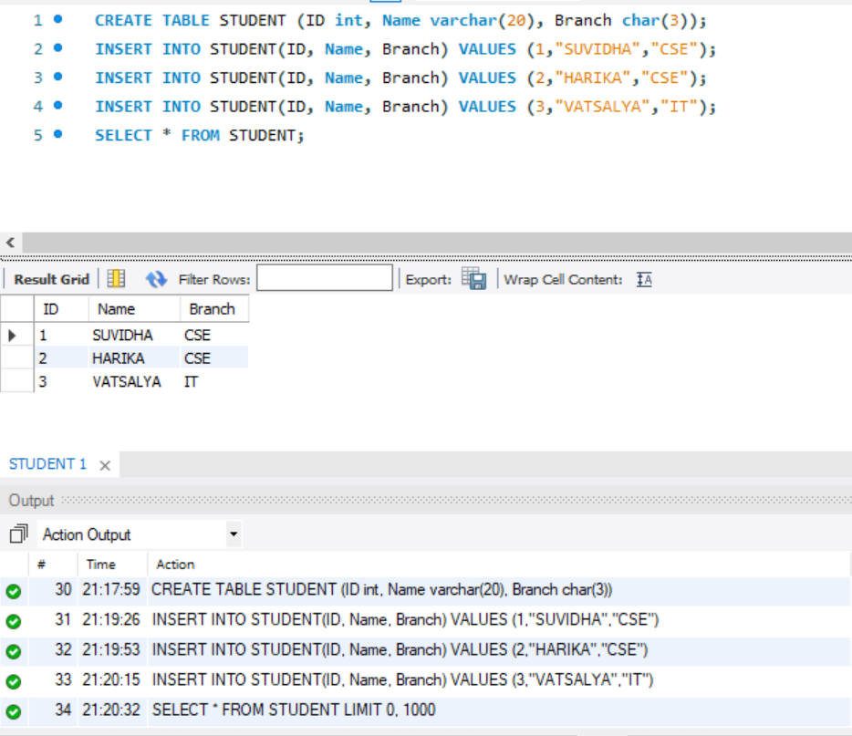

UPDATE

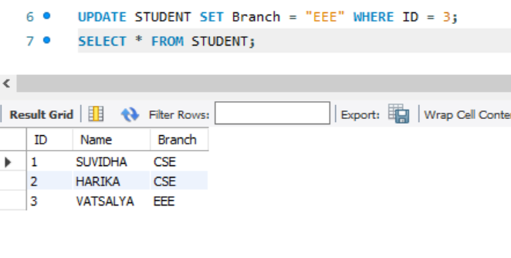

DELETE

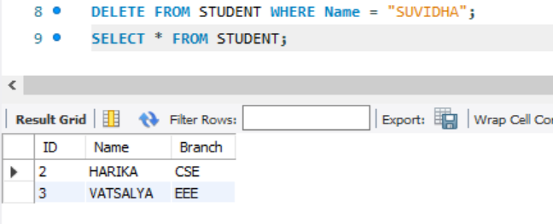

SELECT

